GX50 Data Sheet
Meraki Go Router Firewall Plus
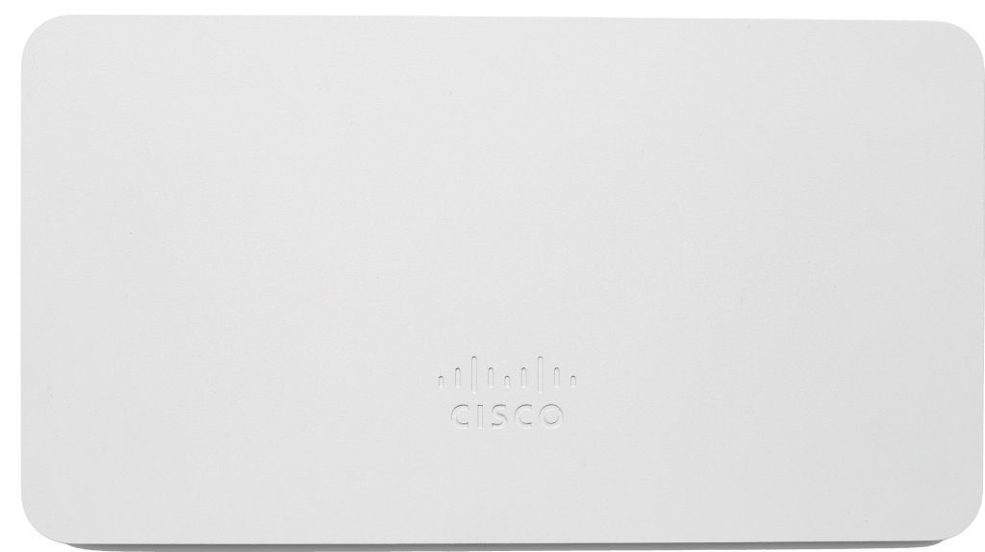
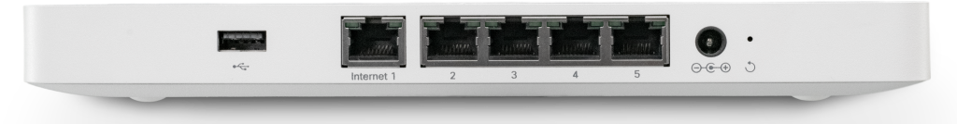GX50

Performance  - Firewall Throughput - 500+ Mbp/s  - Recommended for 50 clients | Interfaces  - WAN Interface: 1x 10/100/1000 BASE-T Ethernet (RJ45)  - LAN interfaces: 4x 10/100/1000 BASE-T Ethernet (RJ45)
Network and Security Services  - Stateful firewall  - Port Forwarding  - DHCP services  - DNS based security powered by Cisco Umbrella (additional subscription required)  - Client VPN | Environment  - Operating temperature: 32 °F to 113 °F (0 °C to 45 °C)  - Humidity: 5 to 95% non-condensing  - Kensington lock hard point
Power  - 18W DC Power Supply Included | Power Load  - 5 Watts idle  - 14 Watts max
Physical Dimensions  - 1.1 x 5.1 x 9.4 in / 27 x 130 x 239 mm, not including deskmount feet or mount plate | Warranty  - 1 year hardware warranty
Weight  - 1.74 lb / 0.79 kg | LED Indicators  - 2 Ethernet status  - 1 power/booting/firmware upgrade status
In the Box  - GX50-HW: Meraki Go Security Gateway  - Wall mount and screw kit  - Quick start guide  - PSU and ethernet cable | Model List / Accessories  GX50-HW-XX Security Gateway - Desktop  GA-PWR-50WAC 50W Replacement Laptop Style Adapter for GX50  XX = US/UK/EU
